Snackel

Version 2.0

By: Team 1

Annie Hahn, Bartosz Dabkowski, Bethel Heo, Jeffrey Asmus,

Mandakhgerel Ganbold, Paul Kessler

Revision History

|  |  |  |  |
| --- | --- | --- | --- |
| **Date** | **Version** | **Description** | **Author** |
| 1/7/15 | 0.1 | Talked to business team to establish requirements | Annie, Bethel, Mandah |
| 1/24/15 | 0.2 | Requirements specification | All |
| 1/29/15 | 0.3 | Use Case diagram | Jeffrey |
| 2/2/15 | 0.3.1 | Use Case descriptions | All |
| 2/4/15 | 0.4 | Activity diagrams | All |
| 2/14/15 | 0.5.1 | Wireframe | Jeffrey |
| 2/15/15 | 0.5.2 | Add title, TOC, Quality control | Bethel |
| 2/21/15 | 0.6.1 | Robustness Diagrams | All |
| 2/21/15 | 0.6.2 | Test Case | Bethel |
| 3/1/15 | 0.7 | Sequence diagrams | All |
| 3/1/15 | 0.7.1 | Class diagram | All |
| 3/4/15 | 0.8.2 | Risk Management | Annie |
| 3/5/15 | 0.8.3 | Problem/Solution | Jeffrey |
| 3/8/15 | 0.8.4 | Executive Summary/ Conclusion/Stakeholders | Bartosz/Mandah |
| 3/8/15 | 1.0 | Financial Summary | Paul |
| 3/17/15 | 1.1 | Manage Snack Use Case, Manage Snack Sequence | Mandah |
| 3/17/15 | 1.1 | Title Page,Search by Location Sequence | Annie |
| 3/17/15 | 1.1 | Sessions Robustness, Sessions Use Case | Paul |
| 3/17/15 | 1.2 | Stakeholder and Developer review changes | Bethel |
| 3/18/15 | 2.0 | Finishing touches for final submit | All |

Table of Contents

1.0 Business Summary 5

1.1 Executive Summary 5

1.2 Stakeholders 5

1.3 The Problem 6

1.4 The Solution 6

1.5 Financial Summary 8

1.6 Risks 9

1.7 Conclusions 10

2.0 Software Requirements Specification 11

2.1 Functional Requirements 11

2.2 Non-Functional Requirements 14

3.0 Wireframe 16

4.0 Architecture Design 17

4.1 Use Case 17

4.2 Domain Modeling 20

4.3 Activity Diagrams 21

4.4 Robustness Diagrams 27

4.5 Sequence Diagrams 32

4.6 Class Diagram 36

5.0 Test Case 37

Appendix 38

Stakeholder Peer Review 38

Developer Peer Review by Double Dragon 40

# 1.0 Business Summary

## 1.1 Executive Summary

Traveling abroad can be difficult and frustrating. Travelers enter unfamiliar environments where they usually experience language barriers that prevent them from fully experiencing the country that they are visiting. In order to get a little taste of culture, many travelers eat the various snacks offered by local vendors. Unfortunately, it is difficult for snack consumers to confidently buy snacks when they are unfamiliar with the packaging and language. Moreover, snacks that look delicious and exotic may turn out to be disgusting. As a result, this causes the traveler to lose money and have a bad experience. These problems could be avoided if the hungry tourist knew what the snack was going to taste like before they bought it.

Snackel is the only mobile application that can successfully connect users to accurate snack reviews. By establishing a database open to user manipulation, app users will be able to post various snacks around the world with reviews that include a summary of the snacks content and a photo of the snacks packaging. Additionally, the application will allow users to search snacks by their current location and by using reverse-image search to match the snacks in the database to the snack being compared.

In regards to economic viability, there is a large untapped market of travelers who need to be informed about the snacks in their local areas. As a result, Snackel has high potential for ad-based revenue. According to the Average Revenue Per User model, every mobile app user is worth $0.04 per month. Since there were 61,569,800 U.S. citizens that traveled internationally in the year 2013, there is a potential for $2,440,000 per year with in-app advertisement for U.S. citizens alone.

## 1.2 Stakeholders

**Internal Stakeholder**

* Team responsible for project planning
* Project scope estimation
* Define work product, task attributes and project life cycle
* Plan data management, project resources
* Review project plan
* Interact with external stakeholders to determine their interest and expectation
* Internal Stakeholders can include: **Employee, Manager, Owner**

**External Stakeholder**

External Stakeholders have different interest, role and responsibilities

Supplier

* Provide reverse image lookup software for the project
* Meet all expectations set by company

Customer

* Helping the business to grow and develop
* Participate in survey or research to improve project

Investor

* Carefully consider all risk, fees and other expenses explained in documents
* Provide accurate information about financial status, and investment goal

## 1.3 The Problem

A common problem travelers have is a lack of confidence when purchasing international snacks. A Snack companies’ packaging and language barriers can overwhelm travelers, preventing sales of snacks. Furthermore, in certain cases, purchasing snacks can lead to travelers experiencing indigestion and other discomforts. Lost sales and experiencing discomforts affect snack businesses and snack consumers. We believe that snack companies are losing out on a potential increase in profits. Moreover, snack companies reputations suffer when causing discomfort to travelers, potentially losing other travelers business.

## 1.4 The Solution

Our organization will develop and support mobile-based applications. Our application will be a data management application for foreign snacks.  This application will provide users with database-driven snack information. Our solutions will provide a rich source for advertising to aid in increasing advertise space sales.

The project will be split into the following phases:

1)  Set up Servers, populate Database

2)  Develop Mobile Application

3) Enhance our user base by establishing a presence in social media

Phase 1:

Our first priority is to configure and populate our central and backup servers through the creation of a database system. The database will consist of locations, snack images, snack ratings/ reviews, and snack information. The database will be flexible for future expansion.

Phase 2:

After the servers are up and running, we will begin development on the mobile applications. The mobile application will provide the following functionality:

* Search Snack by Image- a user uploads a picture of snack in question, compares it to our snacks in the database, and returns reviews and descriptions of the snack.
* Search Snack by Location-allows a user to find popular snacks based on their GPS location. See use case number…
* Rate Snack- allows a user to leave feedback on a snack in the system.
* Send/Receive suggestions – allows a user to suggest snacks to another user in the system.
* Send/Receive warnings – allows a user to warning another user in the system about a snack.

The mobile application will be flexible for future expansion.

Phase 3:

To generate revenue, the mobile application will need to enhance our user base. Our organization will set up Facebook and Twitter accounts to utilize their tools to start our promotion campaign.

## 1.5 Financial Summary

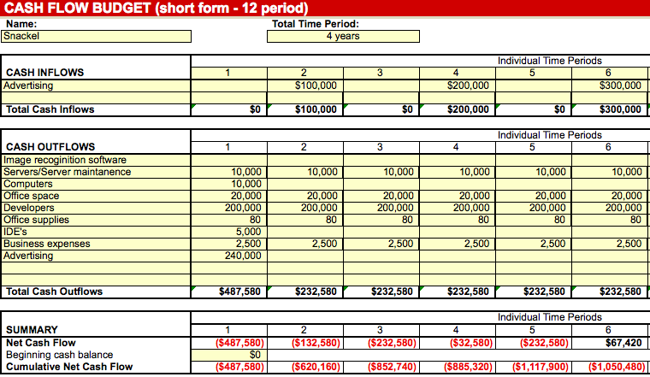

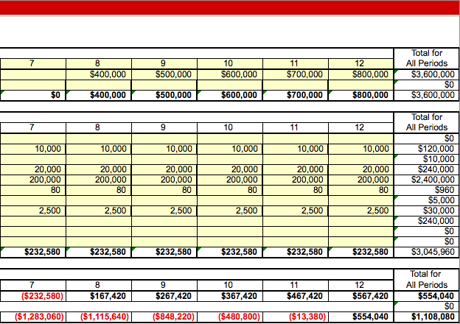

## 1.6 Risks

|  |  |  |  |  |  |
| --- | --- | --- | --- | --- | --- |
| **Risk ID** | **Risk Category** | **Risk Description** | **Impact** | **Probability** | **Risk Control** |
| R-1.0 | Environ-  ment | Application functions are disabled by lack of internet access or censorship | Serious | Remote | Accept: application functions do not work without internet access |
| R-2.0 | Security | User account information is compromised by an outside attack | Critical | Occasional | Avoid: use secure encryption and sufficiently test security functions |
| R-3.0 | Budget | Application does not produce sufficient revenue | Serious | Probable | Reduce/Mitigate: increase marketing |
| R-4.0 | System | Server crashes | Serious | Occasional | Avoid: use dedicated servers and do sufficient load testing |
| R-5.0 | Reliability | Image-matching software does not correctly produce relevant matches | Serious | Occasional | Avoid: test software and ensure compatible versions used |
| R-6.0 | Customer | Application does not have sufficient active users, leaving friend functionalities unused and insufficient entries in database | Serious | Probable | Reduce/Mitigate: advertise app in colleges; increase marketing during spring and summer |
| R-7.0 | Reliability | Database searches take too much time | Serious | Occasional | Reduce/Mitigate: ensure efficient storage of data to facilitate retrievals |
| R-8.0 | Customer | Customers find the application difficult to use | Serious | Occasional | Reduce/Mitigate: create short tutorial to show customers how to use application |

## 1.7 Conclusions

For Snackel to achieve status as an industry leader, it must secure initial capital. This capital will be used for start-up costs such establishing a reliable database. Providing that the company is able to acquire its funding requirements, Snackel should be able to achieve operational success for many years to come.

Snackel has the potential to become a highly regarded application in international countries. Due to the company's establishment as a "unique" entity in its industry, careful development of its software coupled with strategic partnerships with one of the industry's largest tech company (Google), and the company's profitable financial summary, Snackel has the potential to provide lucrative returns to potential investors.

# 2.0 Software Requirements Specification

## 2.1 Functional Requirements

The following functional requirements have been grouped into five categories: Account Management, Snack Management, Image Matching, Location Management, and Social Aspect Management. Account management concerns functions related to the user’s account as well as a user’s public profile and activity within the application. Snack management requirements are concerned with how the snacks are added and found by the application. Image matching requirements are concerned with matching images with their correct snacks. Location management requirements are concerned with finding snack vendors in a radius depending on a user’s GPS coordinates. Social Aspect Management requirements are concerned with aspects of snack reviews, information sharing, and open communication.

**2.1.1 Account Management Requirements**

|  |  |
| --- | --- |
| **Req-ID** | **Requirement** |
| FN-AM-01.0 | User shall create an account to leave a review of a snack or post a new snack. |
| FN-AM-01.01 | User shall be prompted to create an account by entering an email address, username, and password. |
| FN-AM-01.02 | User profile shall be generated based on an email address. |
| FN-AM-01.03 | If username or email address is already taken, user will see a message. |
| FN-AM-01.1 | User shall create a public profile by inputting information including username, hometown, and an optional picture. |
| FN-AM-01.3 | If user chooses not to upload a profile picture, a default one will be assigned. |
| FN-AM-01.4 | User shall be able to edit hometown and picture. |
| FN-AM-01.5 | User shall be able to change account password via email. |
| FN-AM-01.6 | User shall be able to view his or her snack reviews on the profile page. |
| FN-AM-01.7 | User shall be able to view his or her favorite snacks. |
| FN-AM-01.8 | User shall be able to receive an email notification to reset their password, if they forget it. |
| FN-AM-01.9 | User shall have the ability to add snacks as favorites. |
| FN-AM-02.0 | User shall be able to define how to receive notification, such as email or Push/Pop notifications. |

**2.1.2 Snack Management Requirements**

|  |  |
| --- | --- |
| **Req-ID** | **Requirement** |
| FN-SM-01.0 | User can add snack profile by uploading digital images. |
| FN-SM-01.01 | User can upload up to 5 images for each existing snack. |
| FN-SM-01.10 | User can search for snack suggestions by their GPS location. |
| FN-SM-01.11 | User can search for snacks by keywords. |
| FN-SM-01.12 | User can search for snacks by digital images. |
| FN-SM-01.13 | User can search for snacks without being logged in the system. |
| FN-SM-01.2 | User can add snacks by manual text creation. |
| FN-SM-01.3 | User can edit the snacks they have uploaded to the application. |
| FN-SM-01.4 | User can delete the snacks they have uploaded to the application. |
| FN-SM-01.5 | Snacks can store additional snack information (nutritional facts, allergy warnings, price). |
| FN-SM-01.6 | User can vote to delete unhelpful snack reviews. |

**2.1.3 Image Matching Requirements**

|  |  |
| --- | --- |
| **Req-ID** | **Requirement** |
| FN-IM-01.0 | Application shall return top ten matches when a user searches by digital image. |
| FN-IM-01.01 | Application shall return top ten matches when a user searches by keyword. |
| FN-IM-01.20 | Application shall prompt user to upload snack images (if user desires) if match not found. See FN-SM-01.0 |
| FN-IM-01.3 | User shall be able to add tags to images for future searching purposes. |
| FN-IM-01.4 | If image is too large, the application will allow the user to crop/resize their images. |
| FN-IM-01.5 | Application can combine snack reviews if they are for the same snack. |

**2.1.4 Location Management Requirements**

|  |  |
| --- | --- |
| **Req-ID** | **Requirement** |
| FN-LM-01.0 | Pictures taken shall be tagged with the location using GPS. |
| FN-LM-01.1 | User can see a list of cities where a certain product can be purchased. |

**2.1.5 Social Aspect Management Requirements**

|  |  |
| --- | --- |
| **Req-ID** | **Requirement** |
| FN-SAM-01.0 | User shall have the ability to add friends to a list. |
| FN-SAM-01.01 | User shall have the ability to remove friends from the list. |
| FN-SAM-01.1 | User shall have the ability to leave feedback on snacks. |
| FN-SAM-01.11 | User shall have the ability leave 1-5 star ratings on snacks. |
| FN-SAM-01.20 | User shall have the ability to send notifications for snack suggestions to their friends. |
| FN-SAM-01.21 | User shall have the ability to receive notifications for snack suggestions from their friends. |
| FN-SAM-01.20 | User can rate other users’ reviews as helpful or not helpful. |

## 2.2 Non-Functional Requirements

The Non-functional requirements specify the criteria that can be used to judge the operation of a system. This section further specifies our design decisions relating to the interface, and application performance.

**2.2.1 Performance**

|  |  |
| --- | --- |
| **Req-ID** | **Requirement** |
| NF-PF-01.0 | Application shall return at most 10 results in order of relevance upon a snack search. |
| NF-PF-01.1 | Application shall populate search results within 2 seconds. |

**2.2.2 Reliability**

|  |  |
| --- | --- |
| **Req-ID** | **Requirement** |
| NF-RL-01.0 | There shall be enough disk storage available on the servers to accommodate all the current and added information |
| NF-RL-01.1 | Images shall be limited to 600 x 400 pixels |
| NF-RL-01.2 | Application database should be available at least 99.9% of the time |

**2.2.3 Usability**

|  |  |
| --- | --- |
| **Req-ID** | **Requirement** |
| NF-US-01.0 | Application shall conform to Apple style guide for IOS platform. |
| NF-US-01.1 | Application shall conform to Google’s style guide for Android platform. |
| NF-US-01.2 | Application will use the Times New Roman font. Screen Titles will use the 22dp font size, Headers will use  the 18dp font size, Normal text will use 14dp font size and the 12dp font size will be used for special circumstances. |
| NF-US-01.3 | Application shall work in all countries, and comply with international internet censorship laws. |
| NF-US-01.4 | Application will conform to the screen resolutions, for Apple and Android phones/tablets. |
| NF-US-01.5 | Application shall have at most a 10 minute learning curve. |
| NF-US-01.51 | Application shall include a Frequently Asked Questions (FAQ) section. |
| NF-US-01.52 | Application shall include a short 3-minute tutorial for new users. |
| NF-US-01.6 | Application shall include customer support. |
| NF-US-01.61 | Application shall include a Contact Us section, which includes a Snackel company email, phone number and address. |

**2.2.4 Security**

|  |  |
| --- | --- |
| **Req-ID** | **Requirement** |
| NF-SE-01.0 | Login page shall lock out for an hour after 5 failed attempts at the password. |

# 3.0 Wireframe

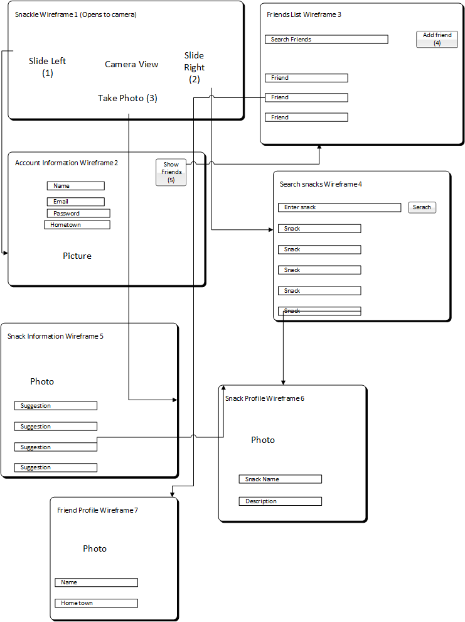

# 4.0 Architecture Design

## 4.1 Use Case

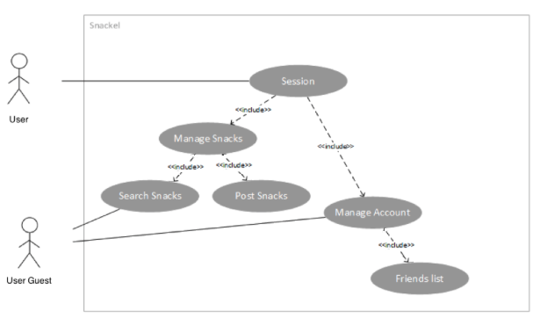

**UC-0 Search by location**

**Name**: Search by location

**Scenarios**:

1. User opens application and selects find snacks by location.
2. Application determines the location of the user.
3. Application returns a list of snacks based on user’s location.
4. Application displays the snack list (starting with highest rating).

**Alternatives**:

     2.  If the application cannot determine the user’s location, an error message is

displayed, and the user is redirected to the home screen.

     3.  If the application returns an empty list an alert message is displayed. Next, the

application will prompt the user to add a new snack. If the user responds yes, the

application redirects to add snack. If the user responds no, the application redirects to

the home screen.

**UC-1 Session**

**Name**: Session

**Scenarios**:

1. User opens application.
2. User is prompted to login with username and password.
3. After the login is successful, the user’s Snackel session is started.
4. During the session the user is allowed to call the friends list use case, the manage account use case, the post snacks use case, the manage snacks use case, and the search by location use case.
5. The user can perform any number of the above activities during the session.
6. The session is closed when the member exits the application.

**Alternatives**:

2a. The user can activate a guest session which is only allowed to perform a picture or

word search of snacks. The guest user can also choose to create an account with a

username and password.

b. If the guest does not have an account, the option to create one with a username

and password will be available.

c. If the user enters the wrong password three times, the user will be prompted to

provide the email account used to create the Snackel account. An email will be sent

to that account with password recovery options.

**UC-2 Friends List**

**Name**: Friends List

**Scenarios**:

1. When the user clicks “Friends List” in their accounts page it will load a page with a list of their added friends.
2. The user can click on one of their friends to see their profile.
3. When viewing a friend’s profile, the user will have the option to send them a message with a link to a snack.
4. The user can swipe the screen right to go back to their friends list.
5. The user will also have the option to remove the friend by sliding the name left and clicking remove.
6. The user can click the “+” button on the top right to add additional friends.
7. When adding additional friends, the user can search by username or email to find ones to add.
8. Once a friend is found, the user can click the add button to send an add request to the friend.
9. In this window there will also be a list of friend requests that the user must accept to allow other users to have them in their friends list. There will be a red number near the “+” button in the friends list window to indicate the number of friend requests pending.
10. When finished, the user can swipe the screen right to go back to their accounts page.

**Alternatives:**

1. If the user has no friends in their list, the page will display “No current friends.”

      7.  If no username or emails match the search, the application will display a message

that there are no matches and prompt the user to search again.

**UC-3 Manage Account**

**Name:** Manage Account

**Scenarios:**

1. If the user is a guest, the system prompts the guest to create a new account by entering an email address and a password.
2. The user can choose to upload a new profile picture or change their hometown.
3. The user can choose to manage their friends (see UC-2).
4. The system displays the updated profile when the actor’s changes are accepted.

**Alternatives:**

1. Email address already exists in the system
   1. System displays, “This address is already associated with an account”
   2. The user corrects field until system accepts address

**UC-4 Post Snacks**

**Name:** Post Snacks

**Scenarios:**

1. The user clicks on the camera in the upper right hand corner of the screen from the Snackel homepage.
2. The user takes a photo of a snack.
3. The user is directed to a new “Write a Review” page.
4. The application will then use image-identification software to determine if there are similar photos already posted.
5. There are no similar snacks posted, so the user is prompted to name the snack, write a review, and give a 1-5 star rating.
6. The user clicks on “Finish Snack Review” and is directed back to the Snackel homepage.

**Alternative:**

     5.   If the photo is similar to snacks already posted into the Snackel database, the user

is asked to look at the top five similar photos and add a review to the one chosen or create a new snack.

**UC-5 Manage Snacks**

**Name:** Manage Snacks

**Scenarios:**

1. If the user is a guest, they can only search snacks (see UC-0).
2. If the user is a logged in member, they can search (see UC-0) or post snacks (see UC-4).
3. The user can create an account at anytime during the search process of snack. (see UC-3).

**Alternatives:**

     2a. If the search for snack wasn’t successful, the application will show similar results to

the user.

      b.  Users cannot post more than 5 snack images under an already existing snack post.

      c.  Users can flag a snack image if they think either the image is too blurry or is

inaccurate.

## 4.2 Domain Modeling

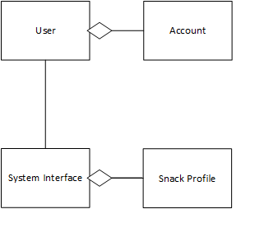

## 4.3 Activity Diagrams

**AD-0 Search by location:**

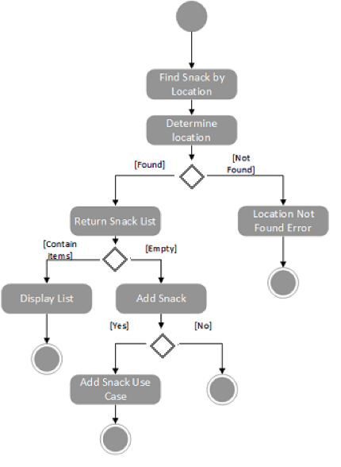

**AD-1 Session**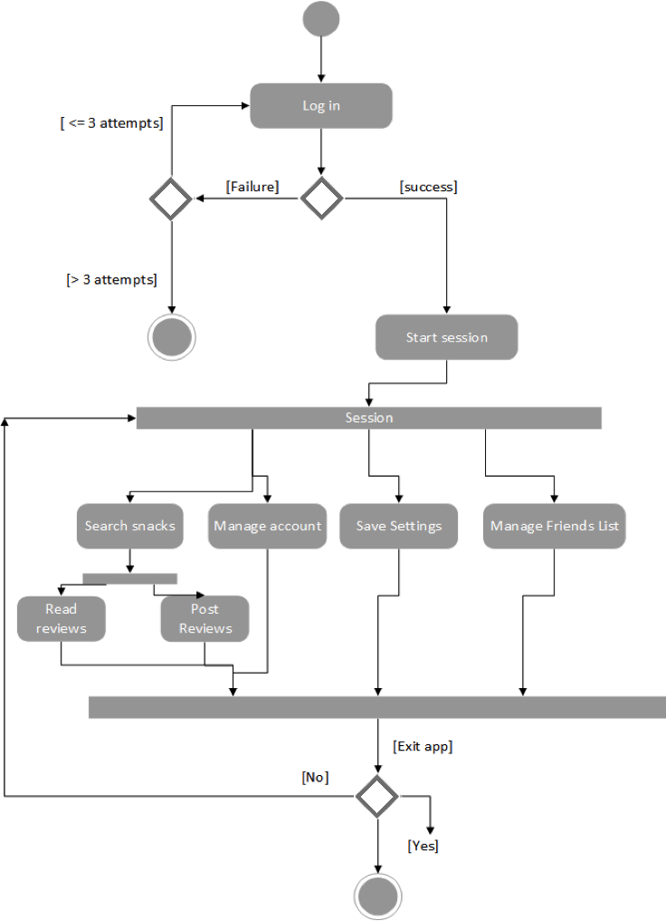

**AD-2 Friends List:**

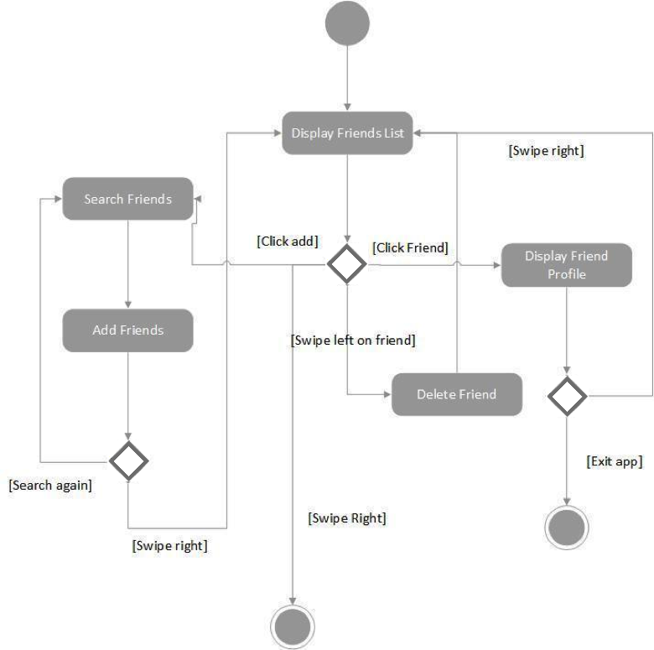

**AD-3 Manage Account:**

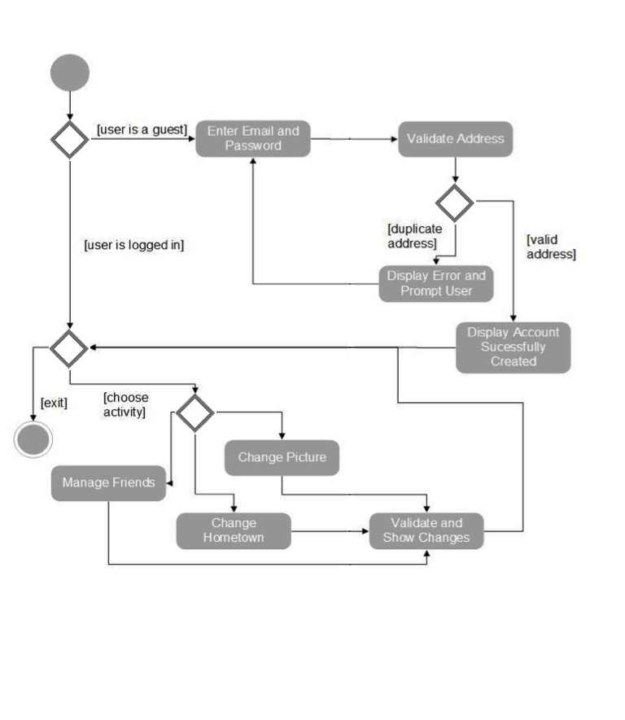

**AD-4 Post Snacks:**

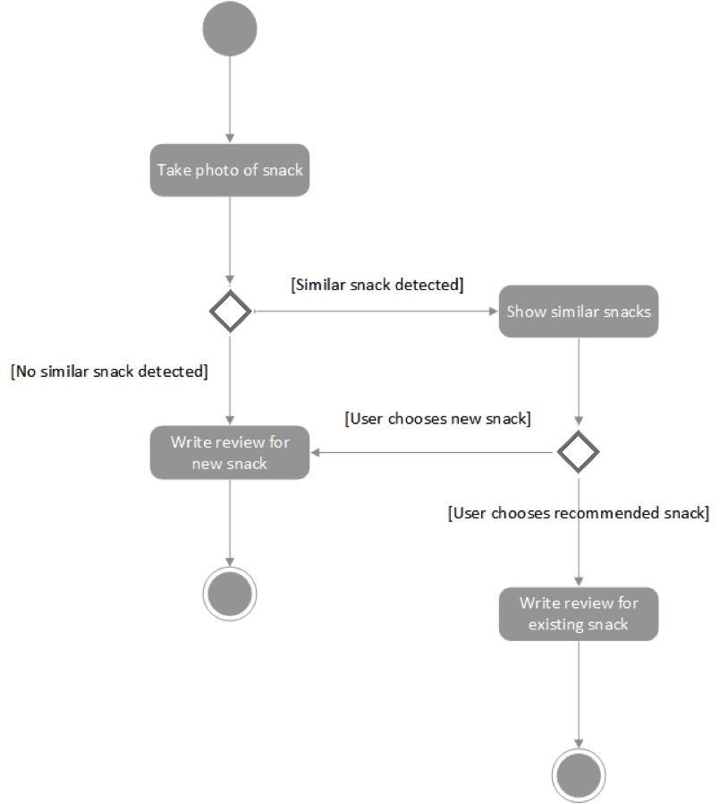

**AD-5 Manage Snacks:**

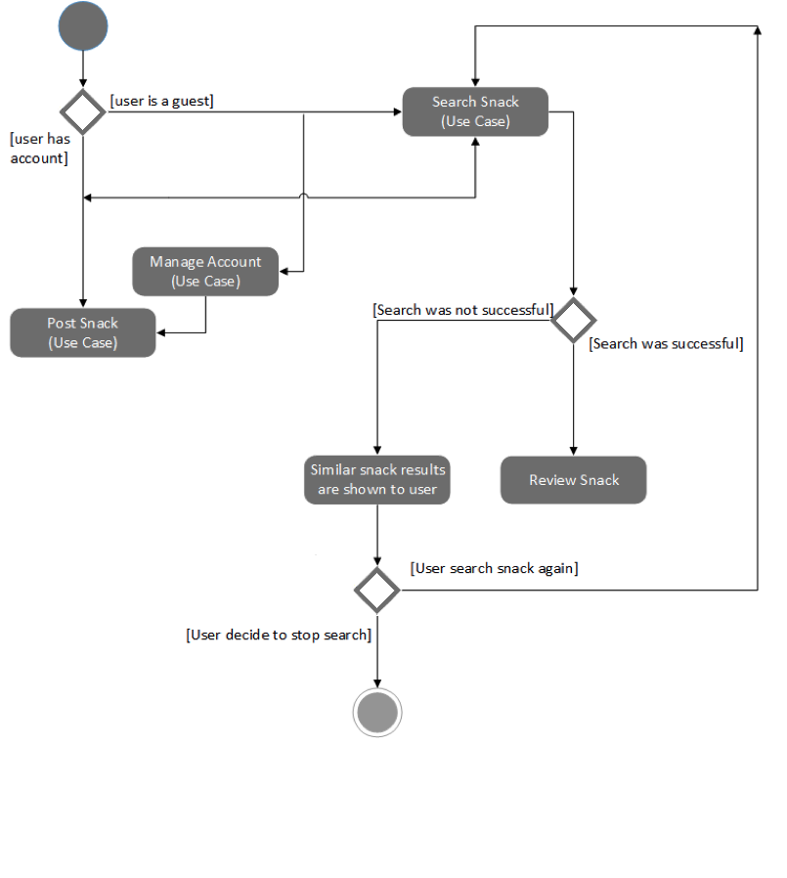

## 4.4 Robustness Diagrams

**4.4.0 Search By Location**

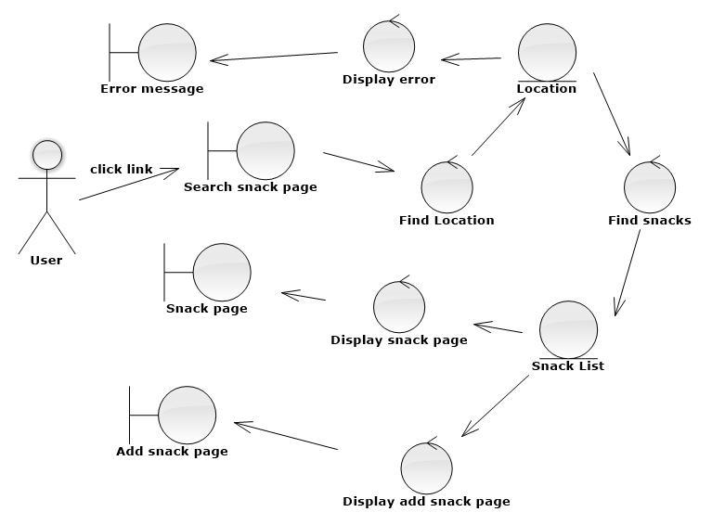

**4.4.1 Session**

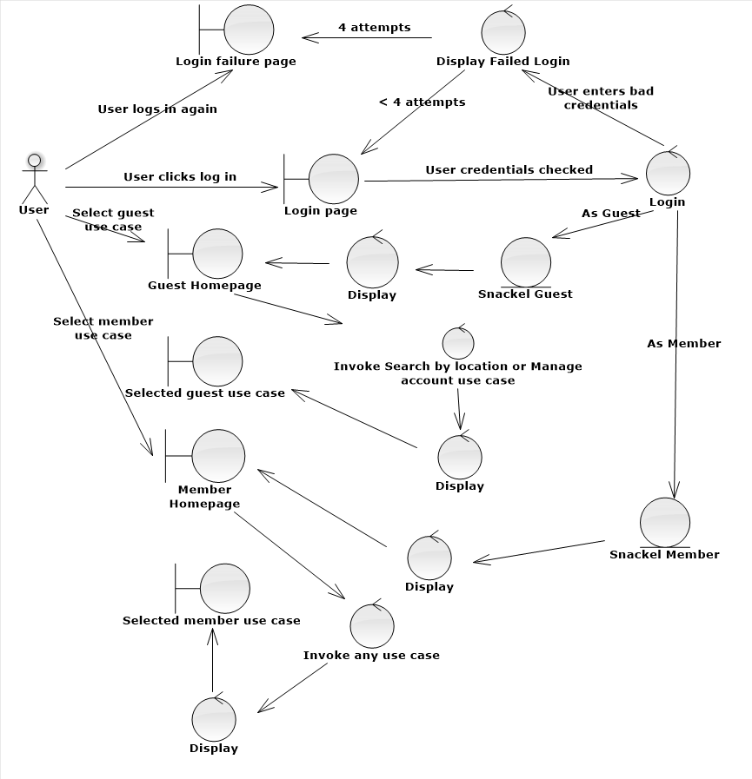

**4.4.2 Friends List**

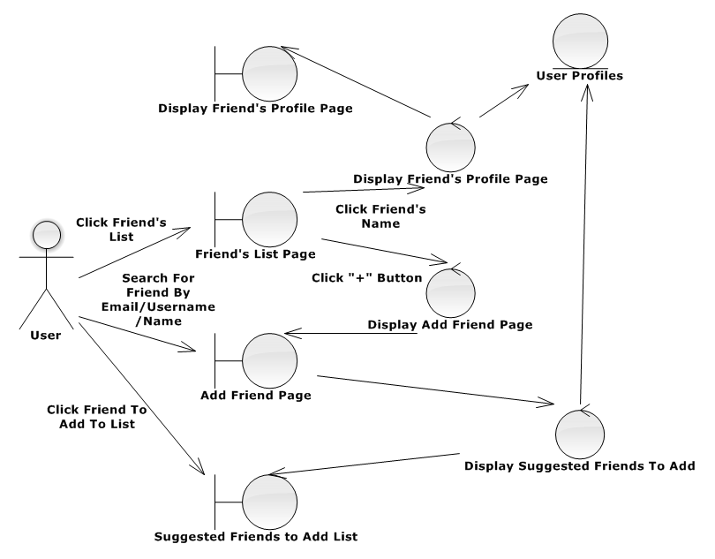

**4.4.3 Manage Snacks**

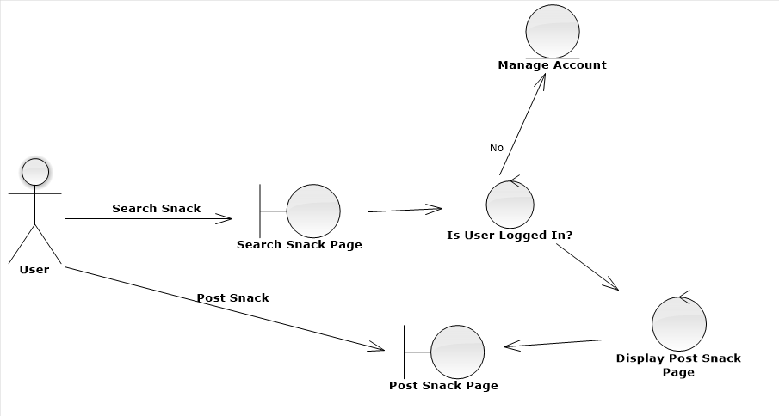

**4.4.4 Post Snacks**

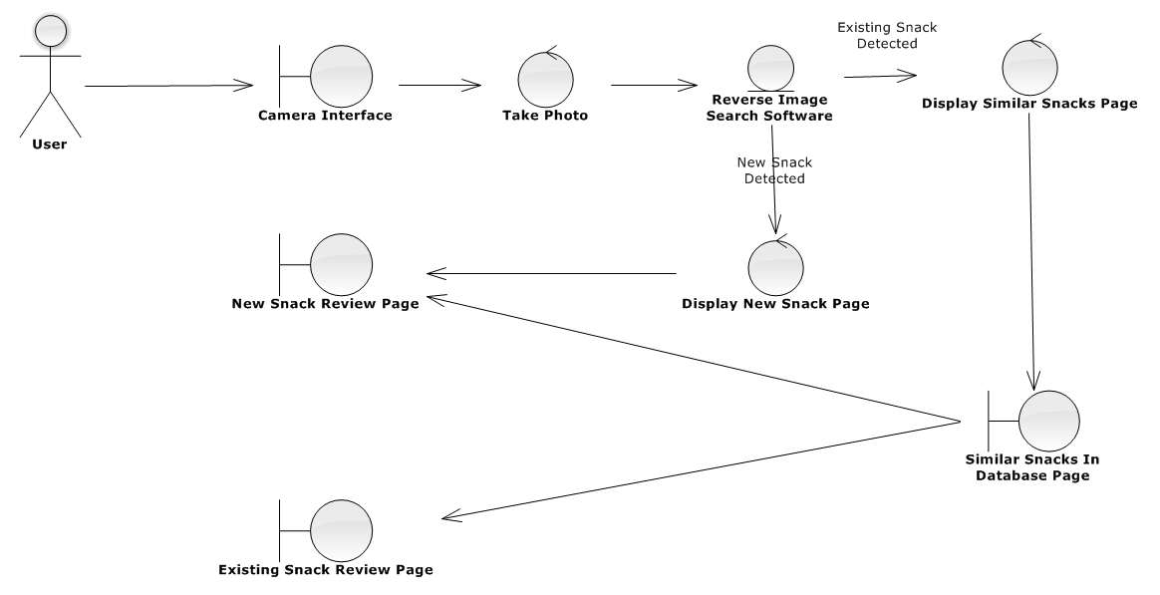

**4.4.5 Manage Account**

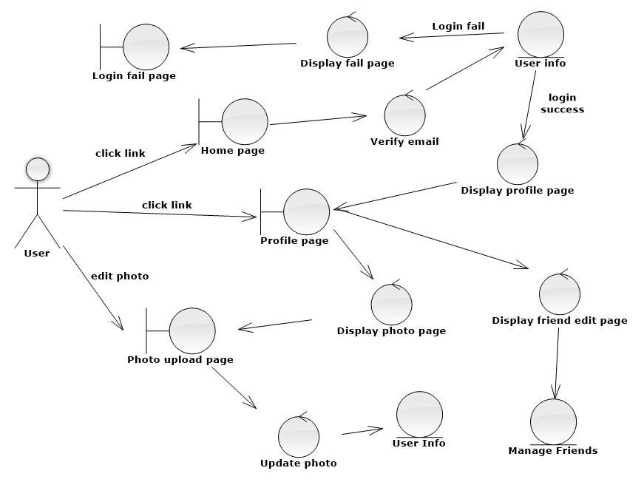

## 4.5 Sequence Diagrams

**4.5.0 Search By Location**

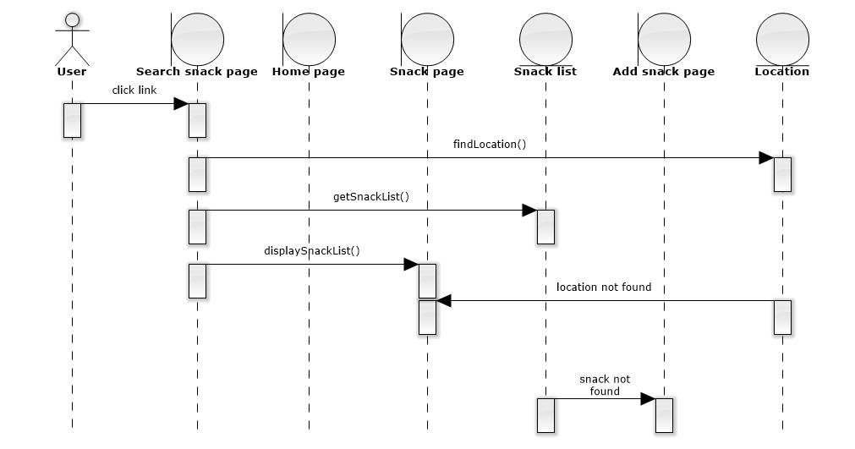

**4.5.1 Session**

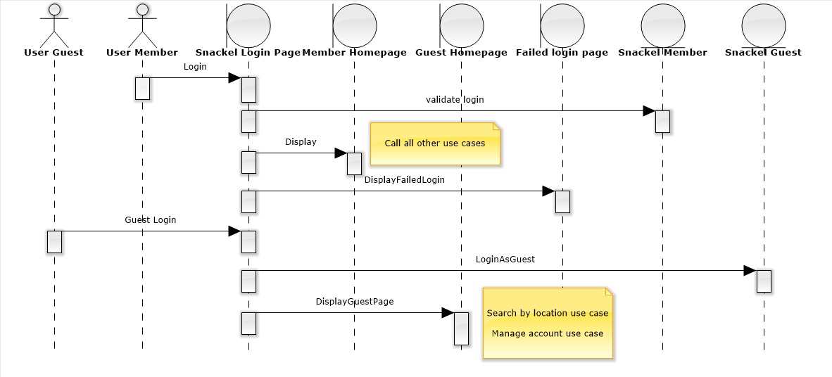

**4.5.2 Manage Snack**

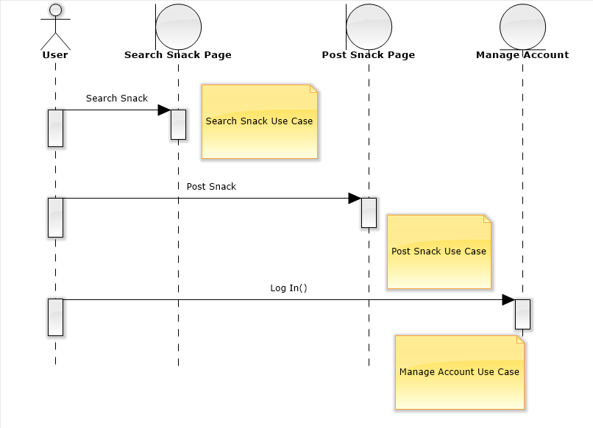

**4.5.3 Manage Account**

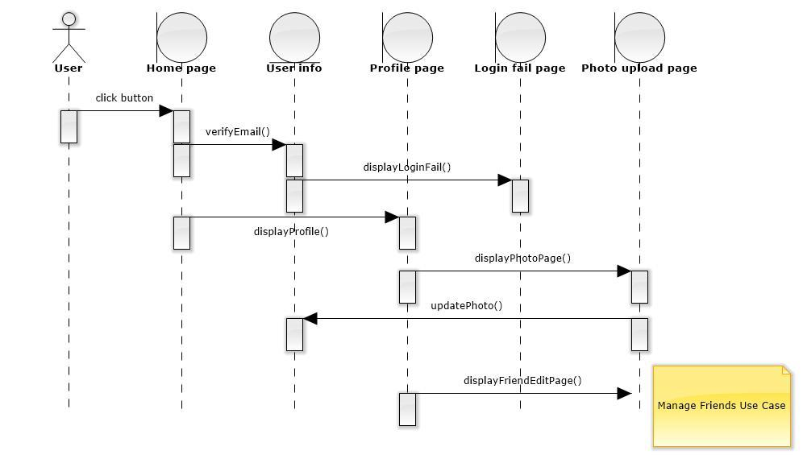

**4.5.4 Post Snacks**

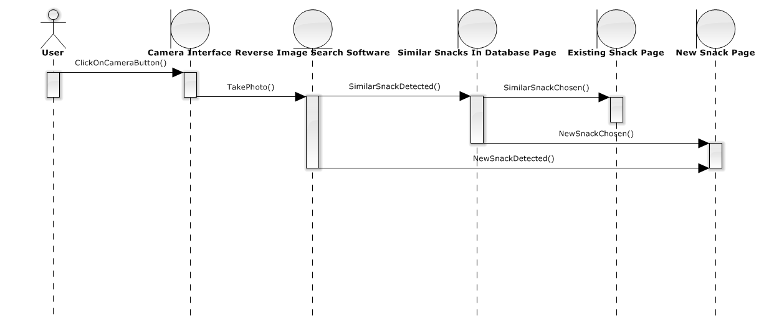

**4.5.5 Manage Friends**

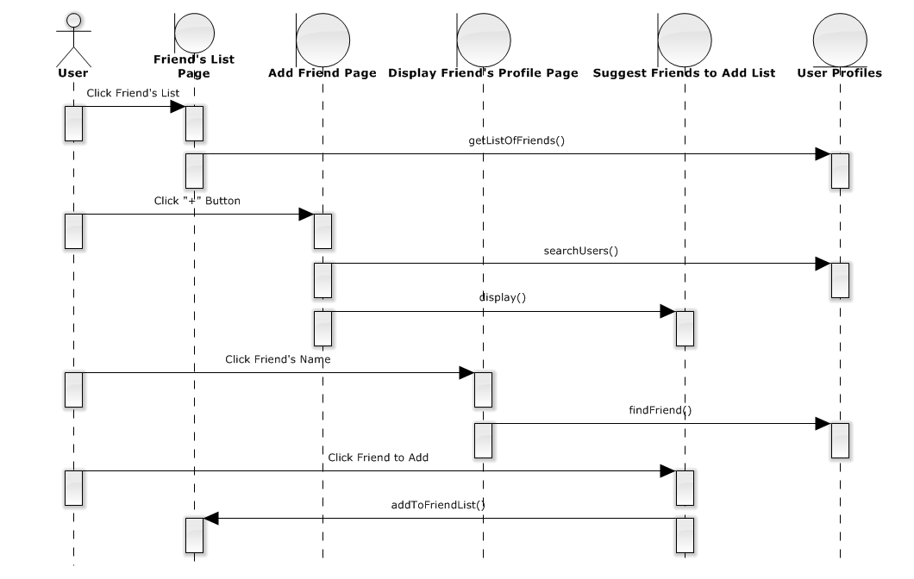

## 4.6 Class Diagram

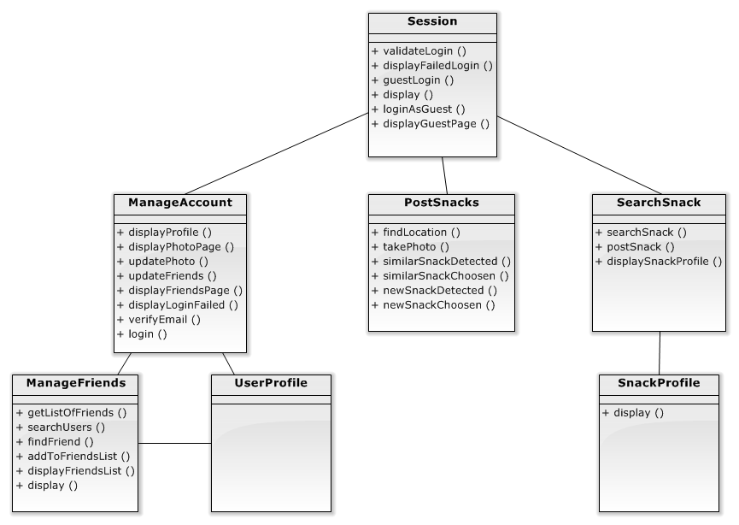

# 5.0 Test Case

|  |  |  |
| --- | --- | --- |
| **Test Case #:** 1.0 | **Test Case Name:**  Search Snack | **Page:** 1 of 1 |
| **System:** Snackel | **Subsystem:** Snack Search |  |
| **Designed by:** Team 1 | **Design date:** 2/21/2015 |  |
| **Executed by:** | **Execution Date:** |  |
| **Short Description:** Test to see if taking a picture of a snack returns relevant results | | |

|  |
| --- |
| **Pre-conditions**  The user or guest has a working camera on their smartphone  The system is displaying the camera to take a picture of the snack  The user or guest has their GPS location turned on |

|  |  |  |  |  |
| --- | --- | --- | --- | --- |
| **Step** | **Action** | **Expected System Response** | **Pass/Fail** | **Comment** |
| 1 | Take a picture of a snack | System uses reverse image lookup to find information on the snack  Displays the closest matches in the Snack Profile database |  |  |
| 2 | Click on one of the suggested matches | System displays the selected Snack Profile page |  |  |
| 3 | **Check Post Condition 1** |  |  |  |
| 4 | Repeat step 1, then click on add new snack | System displays Add New Snack page |  |  |
| 5 | **Check Post Condition 2** |  |  |  |

|  |
| --- |
| **Post-Conditions**  1. Current page displayed is the snack that was selected  2. Current page displayed is the Add New Snacks page |

# Appendix

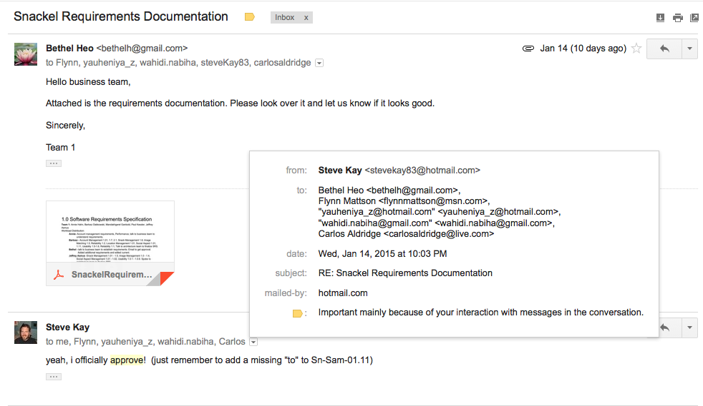

## Stakeholder Peer Review

Superior Six: Nabiha Wahidi, Flynn Mattson, Carlos Aldridge, Steve Kay, Yauheniya Zapryvaryna (Eugenia), Dalia Swellum

We, the Snackel Business team, ACCEPT with CONDITIONS the project proposal. Overall, the architecture team did an excellent job in understanding the problem and providing a workable solution. The Business Proposal is well crafted, convincing, and empathetic toward the issues and needs of both the users and other external stakeholders of the application. The SRS document covers all of the requirements that we specified. Additionally, the financial summary provides a reasonable overview of how much this project is going to cost. However, some sections require revision in order for us to accept this project proposal.

Our main concerns relate to the Risk Analysis and Wireframe sections. The risks need to be analyzed more carefully. Looking at the table, the Risk Analysis seems to suggest that Snackel will be crashing very often and will potentially have many additional problems. Looking at the risks, many of the probabilities and impacts seem unreasonably high to us. For example, in R-1.0, the impact should be serious, and the probability should only be remote, not occasional. Hence, one of our conditions for acceptance of this proposal is that the architecture team carefully look at the risks and reanalyze them to be more realistic.

Furthermore, as a team, we believe that the architecture team's wireframes do not fully cover the full functionality of Snackel. One of the core features of Snackel is to be able to create a new review for a snack and give it a rating. The wireframes that are provided only illustrate the feature of taking a picture and viewing the already existing snack review. As a result, our second condition for acceptance is that the architecture team provide an extra wireframe illustrating what it is like to create a new review for a snack and provide a rating for it. (This is crucial to getting snack information into the database). If these two conditions are met, we will gladly accept the project proposal.

Besides these two conditions, we have some recommendations to make the project proposal better. In the Internal Stakeholders section of the Business Proposal, we believe it would be clearer to list the people falling under that category towards the top of the bullet list so it is clear from the start. In the External Stakeholders section, the architecture team explains that an external stakeholder will be a supplier that will provide materials. What kinds of materials are these? We think that some explanation is needed. Is this infrastructure and related materials for the servers?  Also, in the architecture team's explanation of the problem they mention an “organizational analysis” and a statistic of 8%. What organizational analysis was done? A source for how this statistic was computed would be helpful, and more convincing.

We also had some comments regarding the solution section. Phase 1 says that the database will be filled. How is the architecture team going to fill these Databases? We want to know if the architecture team will allow users to populate the database (in this case the app would need to be up and running) or will people need to be hired to fill the database? We also think that implementation/development should begin while the databases are being set up (change/fix first sentence in Phase 2). In the solution, it is stated that this application has a lot of room for expansion. What kinds of expansions are possible? An example would be nice to have. In addition, the solution as a whole should provide a plan with an actual schedule (months, years, or quarters) and tie it back to the financial summary. We also feel that it is important for the architecture team to mention in the Business Proposal the operating systems for which Snackel will be compatible. We know that this is addressed in the Software Requirements Specification, but it is a nice implementation detail to have in the Business Proposal.

We also had a few comments regarding the financial summary. The financial summary does not take into account utilities and electricity. Also, IDE is currently stated as a cost, when in reality it is free (at least for Android). Additionally, we had a comment regarding wireframes. Descriptions and annotations should be added to enhance the clarity and functionality of every button. Some of the items we could not identify as buttons, text fields, or just rectangles.

Lastly, some formatting (e.g. Risk Analysis table) and grammar issues need to be resolved. Overall, it is a great project proposal. We will gladly accept it after the conditions have been met.

Note: We have inserted annotations throughout the document.

## Developer Peer Review by Double Dragon

After careful analysis of the proposal, Team Double Dragon has decided to Bid for the project with the following conditions listed in the table below. Overall, the design of the project seems viable. However, there are consistency issues within the documentation that make it hard to understand. These issues must be resolved before beginning implementation. Most importantly, the syntax in all of the diagrams differs to each other. This adds confusion and may affect the final product.

In addition, some things seem to be missing from the document. For example, the manage account use case in the robustness diagrams and robustness diagram 4.4.1. It is confusing to view the manage account as one of the storage within the robustness diagram. We do not see any use case been invoked within the sequence diagram; appears that there is a use case diagram specified, but the syntax used was incorrect. We would like to see these things before committing to the project.

We would also like to know what platforms this service will be available, ex android, ios, web. This could significantly affect the development process.

|  |  |
| --- | --- |
| **Section** | **Comments** |
| All | What's the difference between user and user guest? |
| AD-1 | session says if there are more than 3 login attempts the activity *ends*.   * display error and give user option to reset password? |
| AD-0, UC-0 | Activity diagrams AD -0 name inconsistent with UC -0 |
| AD Presentation | Inconsistent   * Sometimes lines appear gray, sometimes black * Some arrows are perpendicular, some have more than one 90 degree angle * Some arrows connect with one another |
| AD-3 | AD-3 has 2 lanes that are split with a solid line, should use dotted line |
| AD-5 | "Post snack" and "review snack" goes nowhere |
| AD-1, 4.4.2 | 4.4.2 Session says "4 attempts" but AD-1 says "3" |
| 4.4.0 | there is no action between user and “Search Snack Page” |
| 4.4.1 | robustness diagram is missing? |
| 4.4.2 | there is no action between user and “Login Failure page” or the “Member Homepage” |
| 4.4.4 | 4.4.4 manage account should be a use case |
| 4.4.5 | Doesn't *camera interface* interfaces with the camera? |
| 4.4.5 | 4.4.5 similar snacks in database page talks to Existing snack review page |
| 4.5.2 | Manage account is a use case not entity object |